DBA PROJECT SCHEDULE (FOLLOW-UP)

# Week 1-3: Proposal Submission and Initial Setup (Already Completed✅)

## Completed Tasks:

* + Submission of project proposal, ERD, and database schema.
  + Database creation and implementation of tables.
  + Basic CRUD operations performed on the tables.

## Student Deliverables:

* + Finalized ERD and database schema.
  + Tables created in the database with dummy data.
  + Queries for CRUD operations.

**Project Proposal  
 DBA & M Fall 2024**

**Title: The Grocery Management System**

**Scenario:**

The Grocery Management System (GMS) is designed to optimize the management of products, suppliers, sales, and user accounts for a retail grocery store. The system ensures seamless tracking of inventory, supplier details, sales transactions, and employee records.

Each product is assigned a unique ID and is associated with a category (e.g., dairy, snacks) and a supplier. Categories define groupings of products, while suppliers include details such as names, addresses, and contact numbers.

The system enables efficient tracking of sales, logging product quantities, transaction amounts, dates, and the users involved in the process. Users represent store employees or administrators, each assigned roles and secure login credentials.

The database ensures data integrity and supports real-time updates. Additionally, it provides a complete history of transactions and stock changes to facilitate operational, analytical, and historical reporting.

**ERD:**

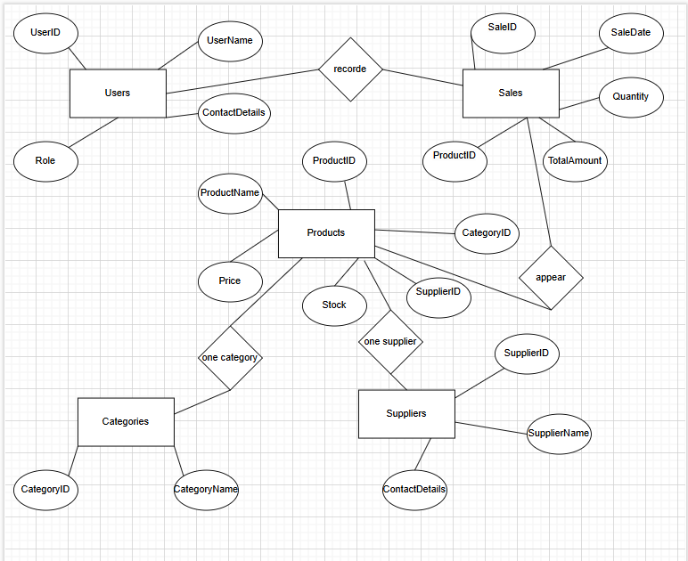

**Conceptual Schema:**

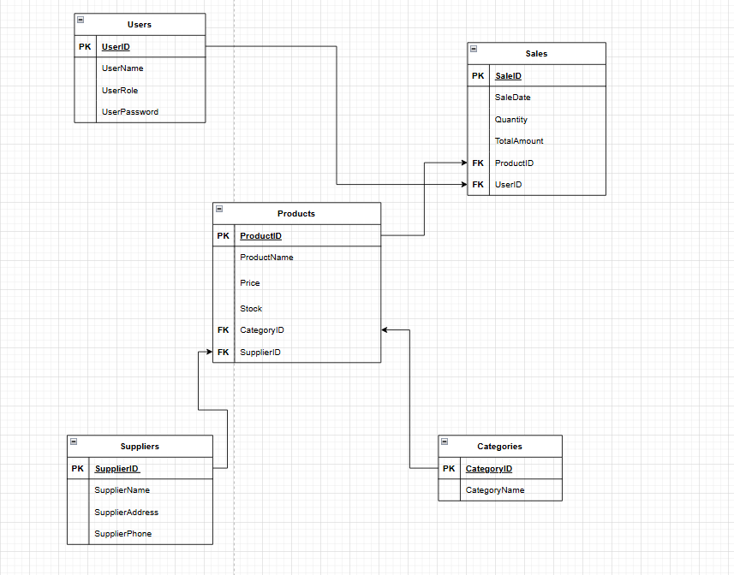

**Table Creation and CRUD:**

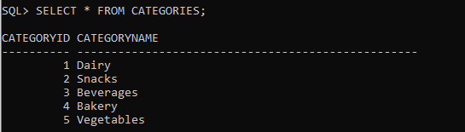

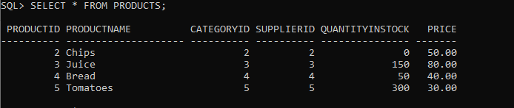

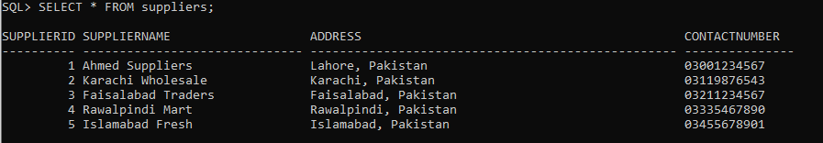

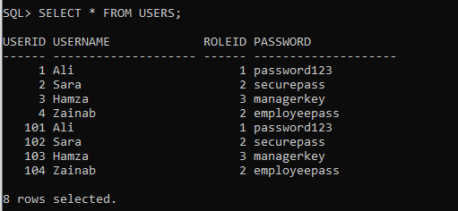

# Week 4: Tablespaces and Undo Tablespaces

## Focus Topics:

* + Creating tablespaces.
  + Managing tablespaces (extending size, adding data files).
  + Creating and managing undo tablespaces.

## Follow-Up:

* + **Create Tablespaces:**
    - In their projects, students must create separate tablespaces for different modules (e.g., STUDENT_TBS, FACULTY_TBS, or BOOKINGS_TBS for marriage hall).

**Create a tablespace for Products and Categories**

CREATE TABLESPACE PRODUCTS_TBS

DATAFILE 'C:/Oracle/oradata/GROCERYMSDBMS/DATAFILE/GMS_PRODUCTS_TBS.dbf'

SIZE 50M

AUTOEXTEND ON

NEXT 10M

MAXSIZE UNLIMITED;

**Create a tablespace for Sales**

CREATE TABLESPACE SALES_TBS

DATAFILE 'C:/Oracle/oradata/GROCERYMSDBMS/DATAFILE/GMS_SALES_TBS.dbf'

SIZE 50M

AUTOEXTEND ON

NEXT 10M

MAXSIZE UNLIMITED;

**Create a tablespace for Users**

CREATE TABLESPACE USERS_TBS

DATAFILE 'C:/Oracle/oradata/GROCERYMSDBMS/DATAFILE/GMS_USERS_TBS.dbf'

SIZE 50M

AUTOEXTEND ON

NEXT 10M

MAXSIZE UNLIMITED;

**Create a tablespace for Suppliers**

CREATE TABLESPACE SUPPLIERS_TBS

DATAFILE 'C:/Oracle/oradata/GROCERYMSDBMS/DATAFILE/GMS_SUPPLIERS_TBS.dbf'

SIZE 50M

AUTOEXTEND ON

NEXT 10M

MAXSIZE UNLIMITED;

## Manage Extends:

* + - Ensure tablespaces are configured to auto-extend for growing project data.

**Extend the size of PRODUCTS_TBS by 100 MB**

ALTER DATABASE DATAFILE 'C:/Oracle/oradata/GROCERYMSDBMS/DATAFILE/GMS_PRODUCTS_TBS.dbf'

RESIZE 150M;

**Add a new datafile to SALES_TBS**

ALTER TABLESPACE SALES_TBS

ADD DATAFILE 'C:/Oracle/oradata/GROCERYMSDBMS/DATAFILE/GMS_SALES_TBS_2.dbf'

SIZE 50M

AUTOEXTEND ON

NEXT 10M

MAXSIZE UNLIMITED;

## Undo Tablespaces:

* + - Set up undo tablespaces to handle rollbacks for CRUD operations during testing.

**Create an Undo Tablespace**

CREATE UNDO TABLESPACE UNDO_TBS

DATAFILE 'C:/Oracle/oradata/GROCERYMSDBMS/DATAFILE/UNDO_TBS.dbf'

SIZE 100M

AUTOEXTEND ON

NEXT 20M

MAXSIZE UNLIMITED;

**Configure the database to use the Undo Tablespace**

ALTER SYSTEM SET UNDO_TABLESPACE = UNDO_TBS;

## Student Deliverables:

* + Evidence of undo tablespaces configured and used.

**Verify Undo Tablespace**

SELECT tablespace_name, file_name, bytes/1024/1024 AS size_mb

FROM dba_data_files

WHERE tablespace_name = 'UNDO_TBS';

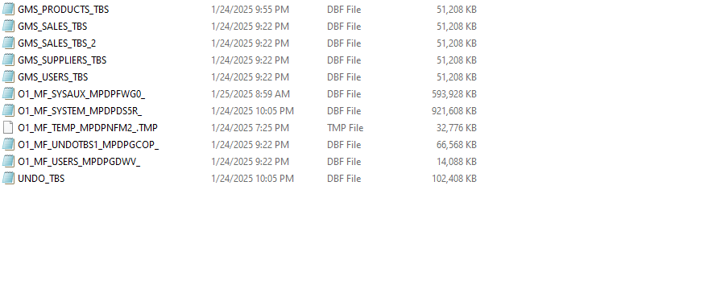

# Week 5: User Management and Quotas

## Focus Topics:

* + Creating users with password expiry.
  + Assigning quotas to users.
  + Dropping users.

## Follow-Up:

* + **Create Users:**
    - Students should create separate database users for modules in their projects (e.g., ADMIN_USER, FACULTY_USER, or CUSTOMER_USER).

**Create Admin User with password expiry after first login**

CREATE USER ADMIN_USER IDENTIFIED BY AdminPassword123

DEFAULT TABLESPACE USERS_TBS

QUOTA 100M ON USERS_TBS

PASSWORD EXPIRE;

**Create Sales User with password expiry after first login**

CREATE USER SALES_USER IDENTIFIED BY SalesPassword123

DEFAULT TABLESPACE SALES_TBS

QUOTA 100M ON SALES_TBS

PASSWORD EXPIRE;

**Create Products User with password expiry after first login**

CREATE USER PRODUCTS_USER IDENTIFIED BY ProductsPassword123

DEFAULT TABLESPACE PRODUCTS_TBS

QUOTA 50M ON PRODUCTS_TBS

PASSWORD EXPIRE;

**Create Suppliers User with password expiry after first login**

CREATE USER SUPPLIERS_USER IDENTIFIED BY SuppliersPassword123

DEFAULT TABLESPACE SUPPLIERS_TBS

QUOTA 50M ON SUPPLIERS_TBS

PASSWORD EXPIRE;

## Assign Quotas:

* + - Assign specific space quotas to users in their tablespaces.

**Adjust quotas for Admin User**

ALTER USER ADMIN_USER QUOTA UNLIMITED ON USERS_TBS;

**Adjust quotas for Sales User**

ALTER USER SALES_USER QUOTA 200M ON SALES_TBS;

**Adjust quotas for Products User**

ALTER USER PRODUCTS_USER QUOTA 100M ON PRODUCTS_TBS;

**Adjust quotas for Suppliers User**

ALTER USER SUPPLIERS_USER QUOTA 50M ON SUPPLIERS_TBS;

## Drop Users:

* + - Drop test or redundant users safely as part of user management.

CREATE USER TEST_USER IDENTIFIED BY Password123;

DROP USER TEST_USER CASCADE;

## Student Deliverables:

* + Screenshots of password expiry prompts and user access tests.

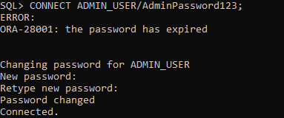

# Week 6: Privileges, Roles, Profiles, and Indexes

## Focus Topics:

* + Granting and revoking user privileges.
  + Creating roles and profiles.
  + Assigning roles to users.
  + Creating and managing indexes.

## Follow-Up:

* + **Grant and Revoke Privileges:**
    - Grant necessary privileges for CRUD operations and revoke them when no longer needed.

**Grant privileges to ADMIN_USER for all tables**

GRANT ALL PRIVILEGES ON Products TO ADMIN_USER;

GRANT ALL PRIVILEGES ON Sales TO ADMIN_USER;

GRANT ALL PRIVILEGES ON Users TO ADMIN_USER;

GRANT ALL PRIVILEGES ON Suppliers TO ADMIN_USER;

**Grant SELECT and INSERT privileges to SALES_USER**

GRANT SELECT, INSERT ON Sales TO SALES_USER;

**Grant SELECT, INSERT, and UPDATE privileges to PRODUCTS_USER**

GRANT SELECT, INSERT, UPDATE ON Products TO PRODUCTS_USER;

**Grant SELECT privilege to SUPPLIERS_USER**

GRANT SELECT ON Suppliers TO SUPPLIERS_USER;

**Revoke INSERT privilege from SALES_USER**

REVOKE INSERT ON Sales FROM SALES_USER;

**Revoke ALL privileges from ADMIN_USER for Products table**

REVOKE ALL PRIVILEGES ON Products FROM ADMIN_USER;

## Create Roles:

* + - Create roles for groups of users (e.g., READ_ONLY, DATA_ENTRY, ADMIN_ROLE).

**Create READ_ONLY role for users who only need to query data**

CREATE ROLE READ_ONLY;

**Create DATA_ENTRY role for users who need to insert and update data**

CREATE ROLE DATA_ENTRY;

**Create ADMIN_ROLE for users with full access**

CREATE ROLE ADMIN_ROLE;

**Assign privileges to READ_ONLY role**

GRANT SELECT ON Products TO READ_ONLY;

GRANT SELECT ON Sales TO READ_ONLY;

**Assign privileges to DATA_ENTRY role**

GRANT SELECT, INSERT, UPDATE ON Products TO DATA_ENTRY;

GRANT SELECT, INSERT, UPDATE ON Sales TO DATA_ENTRY;

**Assign privileges to ADMIN_ROLE**

GRANT ALL PRIVILEGES ON Products TO ADMIN_ROLE;

GRANT ALL PRIVILEGES ON Sales TO ADMIN_ROLE;

GRANT ALL PRIVILEGES ON Users TO ADMIN_ROLE;

GRANT ALL PRIVILEGES ON Suppliers TO ADMIN_ROLE;

**Assign READ_ONLY role to SUPPLIERS_USER**

GRANT READ_ONLY TO SUPPLIERS_USER;

**Assign DATA_ENTRY role to PRODUCTS_USER**

GRANT DATA_ENTRY TO PRODUCTS_USER;

**Assign ADMIN_ROLE to ADMIN_USER**

GRANT ADMIN_ROLE TO ADMIN_USER;

## Profiles:

* + - Define resource limits like session time or idle time.

**Create a profile with session and idle time limits**

CREATE PROFILE LIMITED_PROFILE

LIMIT

SESSIONS_PER_USER 1

IDLE_TIME 30

CONNECT_TIME 120;

**Assign the profile to a user**

ALTER USER SALES_USER PROFILE LIMITED_PROFILE;

## Indexes:

* + - Identify tables in your project where queries can benefit from indexes (e.g., primary keys, foreign keys, search columns). Create, view, and drop indexes.

**Products Table:**

**Primary Key Index**

CREATE UNIQUE INDEX idx_product_id ON Products (ProductID);

**Foreign Key Indexes**

CREATE INDEX idx_products_category_id ON Products (CategoryID);

CREATE INDEX idx_products_supplier_id ON Products (SupplierID);

**Sales Table:**

**Primary Key Index**

CREATE UNIQUE INDEX idx_sale_id ON Sales (SaleID);

**Foreign Key Indexes**

CREATE INDEX idx_sales_product_id ON Sales (ProductID);

CREATE INDEX idx_sales_user_id ON Sales (UserID);

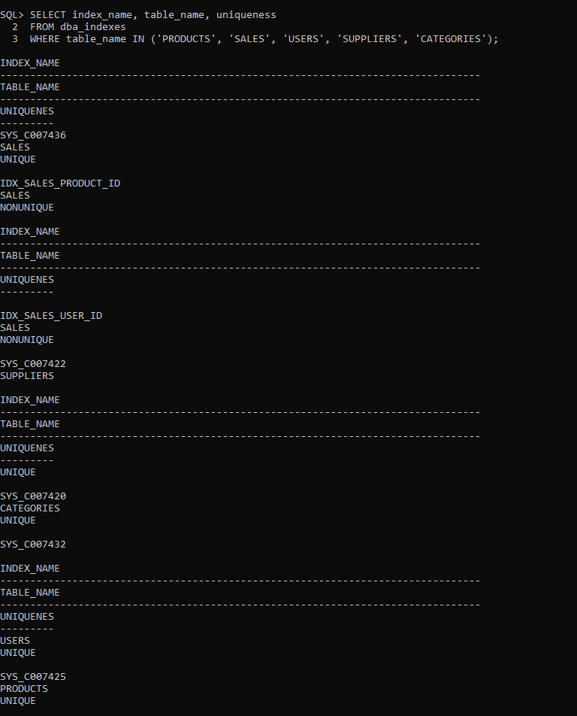

## 

## Student Deliverables:

* + Output showing assigned roles and privileges.

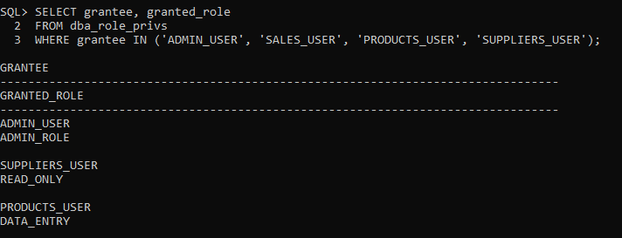

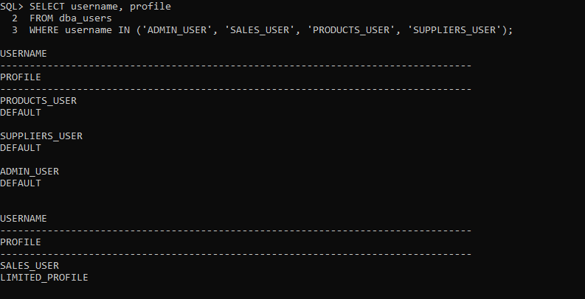

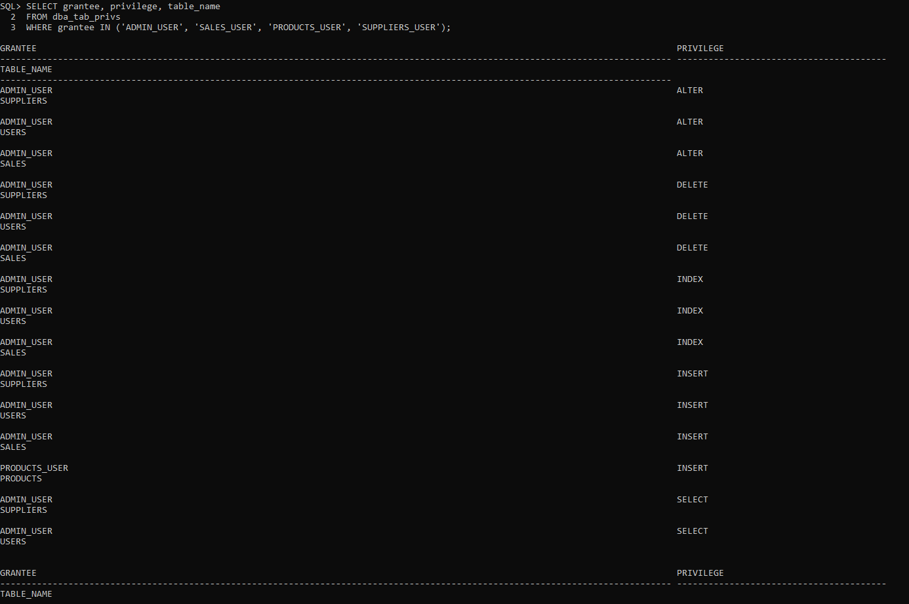

# Week 7: Data Dictionary, Flashback, and Recovery

## Focus Topics:

* + Using the Data Dictionary.
  + Flashback operations.
  + Recovery using RMAN.

## Follow-Up:

* + **Data Dictionary:**
    - Students must query the data dictionary to validate tablespaces, users, and privileges.

**Tablespaces:**

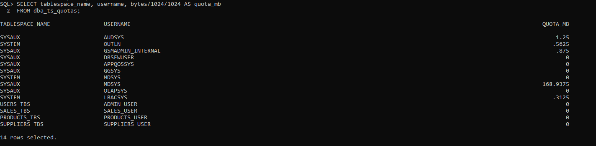

**Users:**

SELECT username, account_status, profile FROM dba_users;

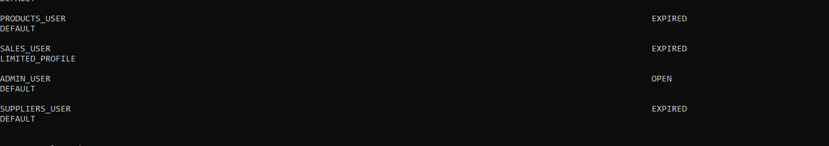

SELECT grantee, privilege, table_name FROM dba_tab_privs;

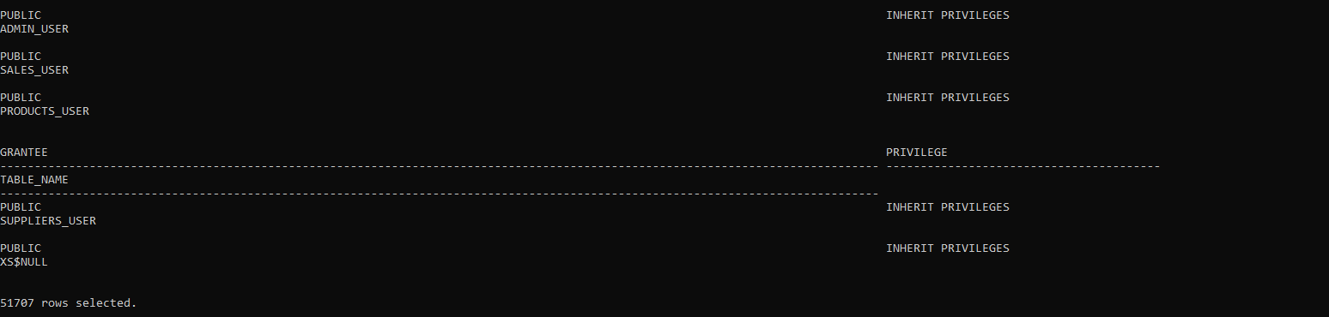

**Roles:**

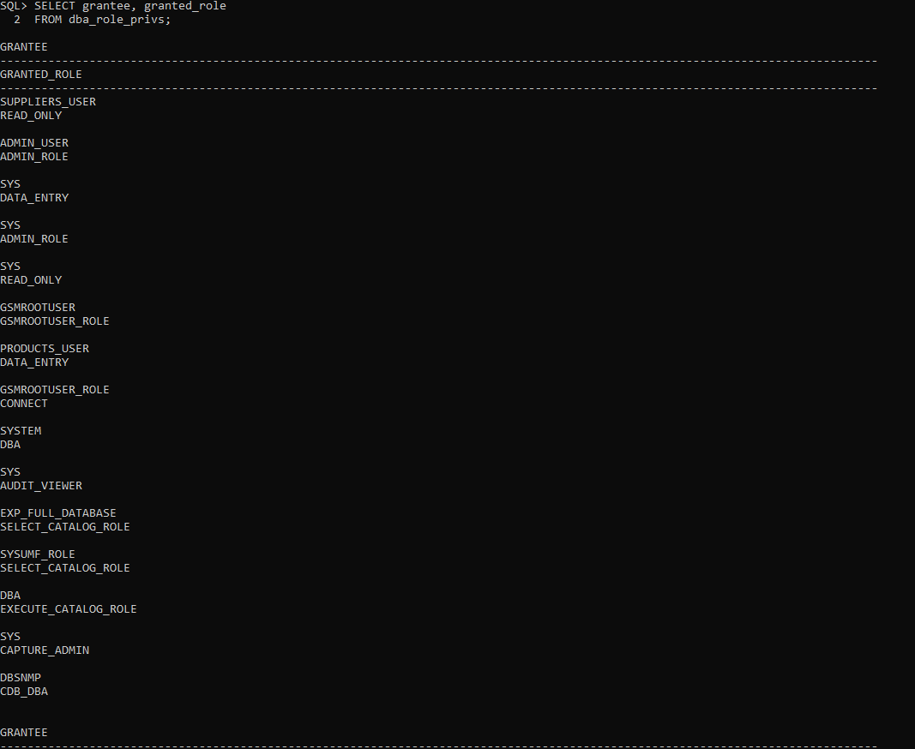

## Flashback:

* + - Simulate data loss or update mistakes in their projects and use flashback to recover data.

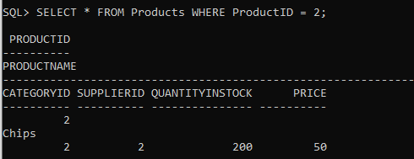

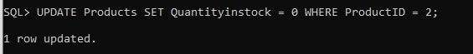

## Recovery Using RMAN:

* + - Simulate data file corruption and recover using RMAN for a module in their project.

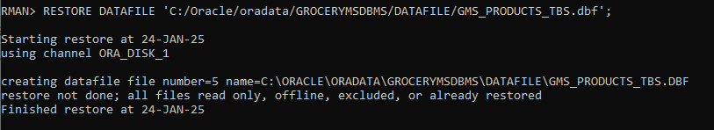

## Student Deliverables:

* + Data dictionary queries and results.
  + Flashback queries and recovery steps.
  + RMAN backup and recovery scripts.

SELECT tablespace_name, file_name FROM dba_data_files;

STARTUP MOUNT;

rman target /

RESTORE DATAFILE 'C:/Oracle/oradata/GROCERYMSDBMS/DATAFILE/GMS_PRODUCTS_TBS.dbf';

# Week 8: Data Dictionary, Flashback, and Recovery

* **Project Viva.**
* **Additional topics (if any).**

# Summary of Deliverables Over 8 Weeks

1. Week 4: Tablespace management.
2. Week 5: User creation, quota assignment, and management.
3. Week 6: Privileges, roles, profiles, and indexes.
4. Week 7: Data dictionary queries, flashback recovery, and RMAN recovery.
5. Week 8: Project viva & additional topics (if any).